**UBS AG $4,593,000 Trigger Callable Contingent Yield Notes Linked to the common stock of U.S. Bancorp due August 13, 2026**

**(I) Introduction**

This study aims to determine the value of Bancorp's common stock, UBS AG Trigger Autocallable Contingent Yield Notes, which is due on August 13, 2026. According to our estimation, the note in question is worth **X**.

Below are a some of the fundamental terms used in the Note:

|  |  |
| --- | --- |
| Key Dates | |
| Trade Date | August 8, 2024 |
| Settlement Date | August 13, 2024 |
| Observation Dates | Quarterly (callable after 6 months) |
| Final Valuation Date | August 10, 2026 |
| Maturity Date | August 13, 2026 |

|  |  |  |  |  |  |  |  |  |
| --- | --- | --- | --- | --- | --- | --- | --- | --- |
| Underlying Asset | Bloomberg Ticker | Contingent Coupon Rate | Initial Level | Coupon Barrier | Downside Threshold | Share Delivery Amount | CUSIP | ISIN |
| Common stock of U.S. Bancorp | USB | 10.25% per annum | $41.76 | $25.06, which is 60.00% of the initial level | $25.06, which is 60.00% of the initial level | 23.9464 shares per Note | 90307DZW5 | US90307DZW54 |

|  |  |
| --- | --- |
| Observation Dates | Coupon Dates |
| November 8, 2024 | November 13, 2024 |
| February 10, 2025 | February 13, 2025 |
| May 8, 2025 | May 13, 2025 |
| August 8, 2025 | August 13, 2025 |
| November 10, 2025 | November 13, 2025 |
| February 9, 2026 | February 12, 2026 |
| May 8, 2026 | May 13, 2026 |
| Final Valuation Date | Maturity Date |

The note's primary characteristics are:

1) There is just one underlying asset for the note i.e. US Bancorp common stock.

2) Based on stock prices on the respective days, the issuer will automatically call the notes on the observation dates (explained later).

3) Depending on the stock values of the underlying asset, US Bancorp, on specific dates, there are contingent coupon payments.

**(II) Approach**

The value of the note in our model has been determined using a __________-step binomial model. Since we are aware of the valuation errors that can occur in a binomial model, we have taken the following actions:

1) Employed a binomial tree with ______ steps, which sufficiently large to reduce the error.

2) Determined the note's value using the **Cox, Ross, & Rubinstein (CRR)** technique. This method allows us to include intricate note properties with flexibility. Additional models will be covered in the report's following sections.

We are aware that even with these precautions, non-linearity errors will exist in the value, mostly because of payments associated with discrete time intervals (the note's autocallable and contingent coupon feature). To ensure that our values are comparable to those provided by other, occasionally more complex models of the binomial method of option valuation, we shall talk about the values obtained from other models.

To ensure the accuracy of our numbers, we have taken data from Bloomberg, a trustworthy source, for the dynamic components of our model. We took the OIS rate (instead of the risk-free rate), dividend yields, and implied volatilities from Bloomberg. The date ranges and moneyness are shown in the screenshots below for your understanding.

**(III) Final Valuation**

We have determined that the note's value is ______ by applying the CRR approach. Next, we will go over the CRR method's components and how it aids in determining the precise values of options and notes of this kind. In order to generate a believable set of note values in the event that some of the components change or are understood differently, we have also performed sensitivity analysis of the model using an acceptable range of volatilities.

Fig 1: Risk Free rate (OIS Rate)

Fig 2: Dividend Yields

Fig 3: Implied Volatility Matrix

**(IV) Valuation Model**

Through the procedures outlined below, we have tried to determine the value of this instrument using the binomial pricing model and input data supplied from Bloomberg.

1. Estimating parameters (u, d, and q) to construct of the binomial tree

Assuming no arbitrage, we estimate the value of the instrument using risk-neutral probabilities discounted at the risk-free rate. We have used the Cox, Ross and Rubenstein (CRR) model to determine the size of the up (u) and down (d) movements where:

u = $ⅇ^{σ\sqrt{Δt}}$ and d = 1/u

The risk-neutral probabilities ( q and 1 – q ) are given by:

q = $\frac{ⅇ^{rΔt}-d}{u-d}$ and 1-q = $\frac{u-ⅇ^{rΔt}}{u-d}$

and r is the OIS rate and $σ$ is the implied volatility (Figure 1 and 3 respectively)

Assumptions:

In the risk-neutral world, all the assets have an expected return equal to the risk-free rate: E[St] = S0ert

Variance of returns = $σ^{2}$ t over a period t.

The underlying asset’s returns are normally distributed over a period t with mean = $\left(r-\frac{σ^{2}}{2}\right)t$ and variance = $σ^{2}$ t : $r_{t}\sim N$ $(\left(r- {0.5 σ}^{2}\right)t , σ^{2}t$).

1. Constructing the stock price tree

We constructed the stock price tree with N = ________ steps and $τ$ = ______ years or _____ days which is the period between the Trade date and the Final Valuation date during which stock price movements are observed to determine the note payoff where:

* i denotes each time step ranging from 0 to N.
* j is the number of up movements in the stock price at each time step (i) ranging from 0 to i.

For example, the stock price (Si,j) at t=0 or the current stock price will be denoted as S0,0 to indicate that we are at time step (i) = 0 and that the number of up movements in the stock price(i) = 0.

We can now calculate the stock price at each node in the binomial tree with N = _____ steps using the formula: $$S_{i,j}=S_{0}u^{j}d^{ⅈ-j}$$

To obtain the stock price at the node S1,1 ( stock price after one time step ( $ⅈ$ = 1) that has moved up (j = 1), we multiple S0,0 with $u$ as (*j* = 1) and 1 (as $ⅈ-j$ = 0).

At the top most node of the tree after N time steps, we have $S_{N,i}$ ( where the stock price after N time steps ( $ⅈ=N)$ has only faced up movements ($ⅈ=j$)) equal to S0,0 multiplied by $u^{j}$ (as $ⅈ=j$ i.e. the stock price has gone up $j$ times) and 1 ( $(as i-j=0)$ i.e. the stock price has not faced any down movements).

Additionally, we have factored in proportional discrete dividends using the dividend yield data obtained from Bloomberg (Figure 2) and the forecasted ex-dividend dates obtained from

<https://www.dividendmax.com/united-states/nyse/financial-services/us-bancorp/dividends>.

Dividends for U.S. Bancorp Equity are paid quarterly, and we have captured the drop in stock price from St(1-D) at the nodes on the time steps corresponding to ex-dividend dates.

1. Constructing the valuation tree using backward induction

After we have the stock price tree, we constructed a new tree i.e., the valuation tree, where we start by specifying the note’s value corresponding to each node of the stock price tree at maturity, which is equal to its payoff at maturity. The payoff of the UBS AG Trigger Autocallable Contingent Yield Notes at maturity as follows:

Payoff = VT,j =

where T = Maturity Date, Principal Amount = $10, ST = Stock Price at maturity and B = Downside Threshold level or Coupon Barrier and $j$ = 0 to N.

In our valuation tree, since $τ$ corresponds to the final valuation date, we discount the payoff at maturity as stated above by the risk free rate $\left(r_{τ,T}\right)$ between the maturity date (T) and the final valuation date $(τ)$.

Payoff = $V_{τ,j}$ = $\left\{\begin{aligned}\left(Principal Amount+Coupon\right)* ⅇ^{r_{τ,T}\left(T-τ\right)} \\ Principal Amount*\left(1+Underlying Return\right) * ⅇ^{r_{τ,T}\left(T-τ\right)}\end{aligned}\right.$ $\begin{aligned}ⅈfS_{T}≥B \\ ⅈfs_{T}<B\end{aligned}$

Using backward induction and the binomial formula: Vi,j = (q * Vi+1,j+1 + (1 – q) * Vi+1,j), we obtain the value of the instrument at all nodes in the binomial tree with N = _______ steps. However, we need to adjust the payoff at the time steps corresponding to the observation dates to obtain the value of the note which incorporates the value of its complex features i.e., the contingent coupon and auto callable features.

* At each of the observation dates, for $B≤S_{T}≤K$ (observed in the stock price tree at the time step corresponding to each observation date), on the corresponding to the observation nodes of the valuation tree, we adjust the payoff to Vi,j = (q * Vi+1,j+1 + (1 – q) * Vi+1,j) + Coupon * e-rδ,
* For $S_{T}≥K$, the payoff is adjusted to Vi,j = Principal Amount + Coupon * e-rδ,

where δ = number of days between the observation date and the coupon payment date and K = Call Threshold Level

Finally, we obtain the values corresponding to the node V0,0 on the valuation tree and estimate the final value of the note after performing a sensitivity analysis of the model(discussed ahead).

**(V) Analysis and Discussion**

Sensitivity analysis and the parameters employed

This section includes a sensitivity analysis utilizing a range of possible volatilities and a discussion of the accuracy of our input values.

Dividends:

For instruments with a single stock as their underlying asset, like in our instance, the proportionate discrete dividends approach yields an adequate valuation. In contrast to the fixed size discrete payouts approach, this method guarantees that the binomial tree recombines at every time step, preserving the model's simplicity. Despite being the simplest to model, the continuous dividends technique does not accurately represent real-world situations because dividends are nearly usually given on specific dates.

Implied Volatilities:

Option prices' indicated or risk-neutral volatilities are reliable indicators of actual volatility. We have performed a sensitivity analysis to determine a set of values for the note as follows, using volatilities for a range of moneyness from ______% of original stock level to ______% of initial stock level over a period of ____ months (time to maturity):

Sample Table:

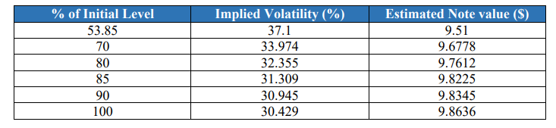

By taking into consideration the volatility at ___% of the starting level, we are essentially overvaluing the note by underestimating the likelihood that St < B.

Conversely, considering the volatility at ____% of initial level, the note will be undervalued because of overestimating the likelihood that St < B.

Therefore, by averaging the computed set of values above, we determine the note's value to be $____. This lessens the chance that we will overestimate or underestimate the likelihood that St will fail above the call threshold level or below the coupon barrier.

Errors pertaining to the binary model

Large errors occur when pricing complicated instruments with characteristics like auto call and discrete coupon barriers using binomial methods. However, because the non-linearity error (described below) only occurs at discrete periods in time, the errors for discrete barrier instruments are smaller than those seen for continuous barrier alternatives.

*Error in distribution:* In a binomial model, we assume that the underlying asset follows the binomial route, meaning that its values change discretely at each node of the binomial tree. This assumption is irrational and results from the tree's discontinuity. To guarantee convergence to the real value or the value with the least amount of error, we can solve this issue by increasing the number of stages in the tree. The graphs below, which display note values for different time steps from 50 to 1096 and 4384 to 4500, show how the note value converges. The value derived from a tree with 10960 steps is contrasted with this*.*

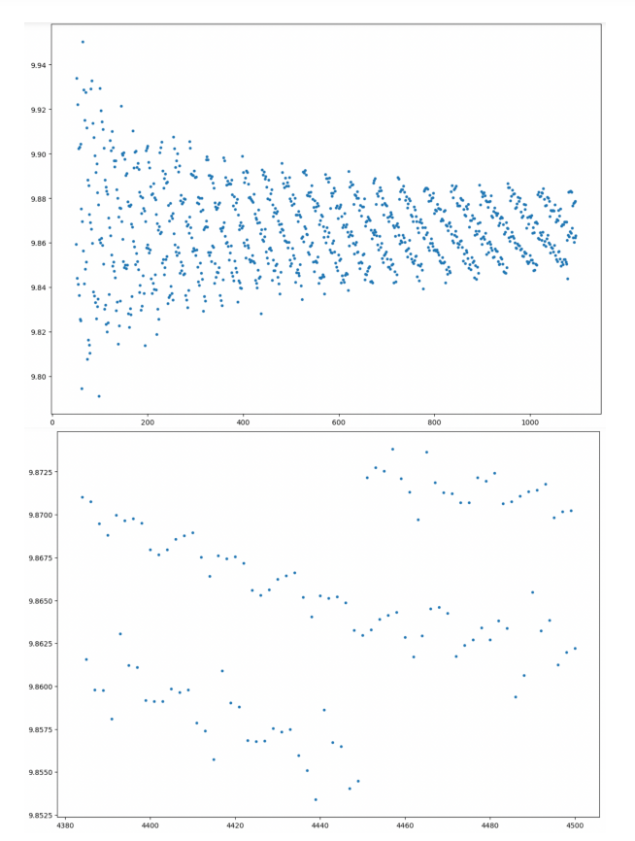

The aforementioned graphs demonstrate that, after 1096 steps, the value converges to the value with the minimum possible error.

*Non-Linearity Error:* The effective strike/barrier, which is represented by the stock price node nearest to the designated strike/barrier, tends to undervalue or overvalue the note when the exercise price or barrier does not precisely fall on one of the nodes in the binomial tree. Since the mistake occurs at every observation date rather than only at maturity, it is comparatively larger for discrete barrier choices.

Method of estimation for the u and d parameters

For the binomial model, we have estimated the u and d parameters using the Cox, Ross, and Rubenstein (CRR) approach, which keeps the model straightforward while providing the flexibility to include intricate aspects of interest. Because it is difficult to modify to value instruments with different levels of complexity, the Leisen and Reimer (LR) technique does not offer this flexibility. Vanilla options were particularly valued using this manner. Using the Black-Scholes model to obtain values at (T - ∆t) and the notion that all options are European options between (Τ - ∆t) and maturity (Τ), the Broadie and Detemple (BD) technique eliminates non-linearity mistakes at maturity. However, due to the poorly behaved maturity payoffs, we are unable to use this method for the note's value. Furthermore, the BD approach only eliminates non-linearity error at maturity; it ignores errors that occur at each observation date.